SPECIFICATION SHEET 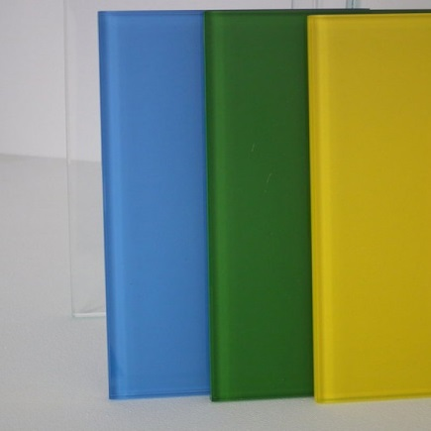
GD BACK PAINTED AND SPLASHBACKS
Using the Makor automated four gun glass coating system Glass Design Back Painted Glass gives architects, builders, designers and homeowners a glass product that is extremely flexible to work with. Ideal for kitchens, bathrooms and splash backs, back painted glass is normally applied to Low Iron glass between 6-19 mm thicknesses and toughened to BS6206 class A.
- Choice of any RAL or DULUX RAL or Dulux colour
- Cost effective
- Almost every type of glass can be coated
- Easily cleaned
- No grouting required - Easy to follow installation guide
- Durable and heat resistant
- Can be cut or drilled to accommodate fixtures and fittings
- Colourfast, and non-staining
- Minimal joins required
- Reduced wall preparation
- Consistent colour
- Available in large sizes 1700 x 3200 mm

Available: Glass Designs Ltd
Contract Shower Division
Unit 3-4 City Cross
Salutation Road
London SE10 0AT
0208 858 8050

Email: info@glass-designs.net
Web: www.glass-designs.net
Web: www.glassdesignshowers.co.uk

