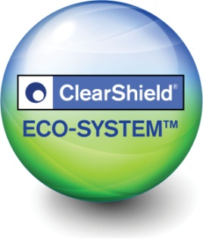
'Non-stick' ClearShield Eco-GlassTM …
A Unique Window of
Opportunity!

ClearShield® just got bigger, better and greener!

Ritec is introducing its award-winning ClearShield Eco-System™ offering window manufacturers and installers in the UK a unique opportunity to...

- Stand out from competition & delight your customers
- Win new business
- Sell more windows and/or make more profits

And we are so confident of your success that we offer a 100% satisfaction guarantee or your money back* for your complete peace of mind.

So how does it work and what does it mean to you?

Working like ‘non-stick’ cookware, the ClearShield Eco-System™ upgrades unprotected glass into ‘Non-Stick’, Easy-Clean, Low-Maintenance Eco-GlassTM.

To your customers, it means
- Maintaining glass clarity, visibility and cleanliness
- Reduces cleaning time, effort and frequency by up to 90%
- Keeping windows looking like new and sparkling
- Helping to maintain the windows Energy Rating

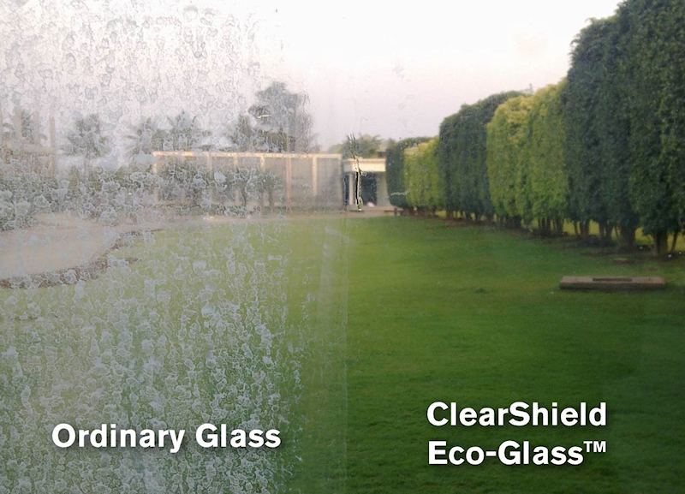

To you, it means

- Added Value & Higher profits without needing to sell more windows.

The proven perceived value of ClearShield Eco-GlassTM is such that you can charge a higher price or reduce the need for discounting.

- Increased Sales offering something no-one else has.

Unique Selling Points for more leads and referrals, closing more sales.

- Start up new retailers with products that stand out and effective Point of Sale Displays.

- No risk – Everything to gain nothing to lose

- Very little investment: launch a new product without the costs
- Guaranteed Performance: more than 30 years of proven results
- Satisfaction Guaranteed: for complete peace of mind

- Happy customers and less call backs

ClearShield Eco-GlassTM helps maintaining promised Energy Ratings and saves your customers cleaning time and effort, achieving more satisfactory results for pristine windows that they can be proud of.
Aged dirty glass
ClearShield Eco-Glass™
ClearShield Eco-Glass™
Aged dirty glass

The ClearShield Eco-SystemTM Easy Start-Up Package
Our Start-Up Package is easy to integrate with incredibly low set up costs.

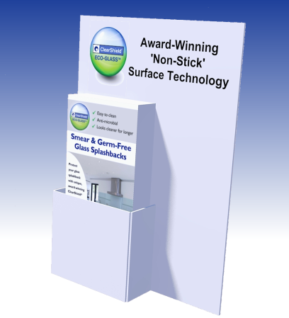
- Safe application methods and equipment
- Customisable Point of Sale Displays
- Application, technical and commercial training
- 5 star on-going support and assistance
- Joint visits to retailers to help them sell more
- 100% satisfaction guarantee or your money back*

Contact our team today for an easy and successful launch of the ClearShield Eco-System®!
^{* Terms & Conditions Apply.}
Ritec International Limited, Innova House, Innova Science Park, 4 Kinetic Crescent, Enfield, EN3 7XH, UK
T: 020 8344 8210 • F: 020 8344 8211 • info@ritec.co.uk • www.ritec.co.uk

